**Step 1:** installed XAMPP for windows version 1.7.3

**Step 2:** Start following modules

* Apache
* MySQL

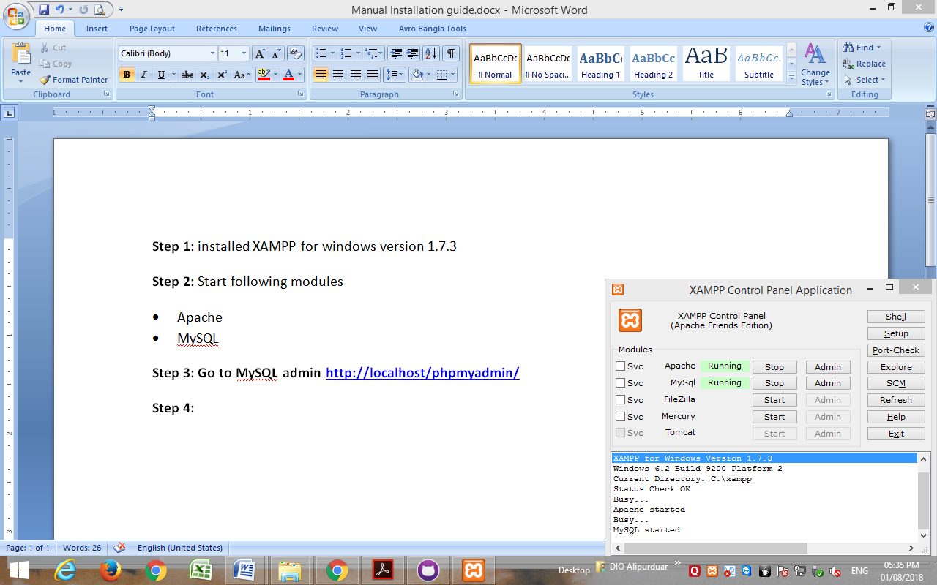

**Step 3: Go to MySQL admin** [**http://localhost/phpmyadmin/**](http://localhost/phpmyadmin/)

**Step 4: Import the DB using .sql file from “My SQL Database file”**

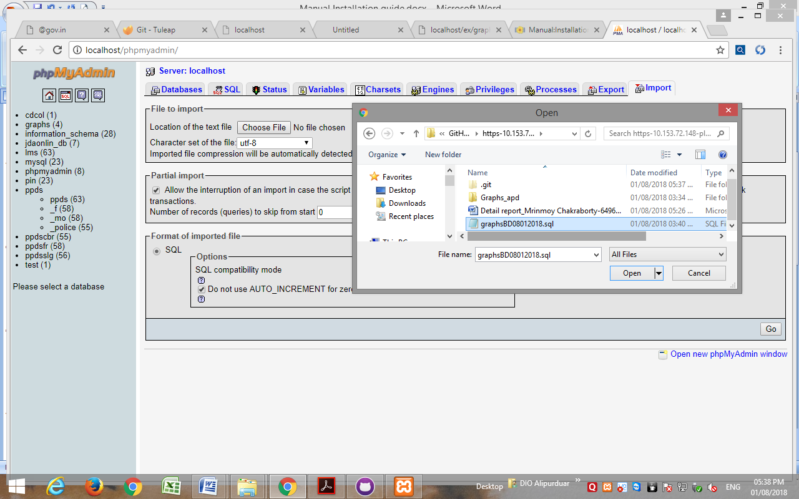

**Step 5:** Go to the path “C:\xampp\htdocs” and paste the php files containing ‘Graphs_apd’ folder.

**Step 6**: Then go tointernet explorer/Mozilla Firefox**/**Google Chrome. And enter the following

<http://localhost/Graphs_apd/graph.php>

